DELTA THETA CHI SORORITY
NATIONAL OUTLINE
2023-2025

“EXTRAORDINARY WOMEN WHO CHANGE HISTORY’

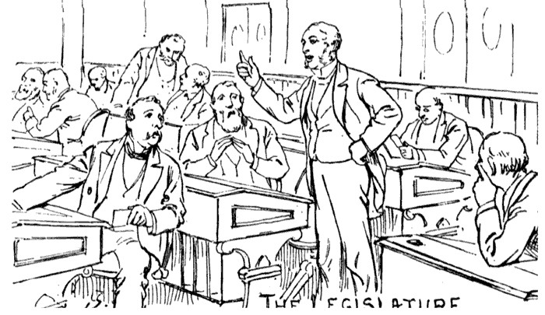
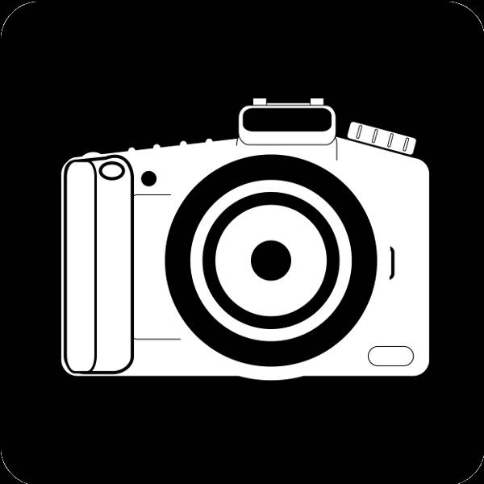
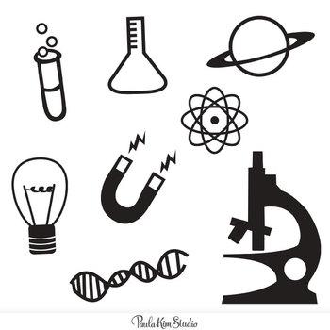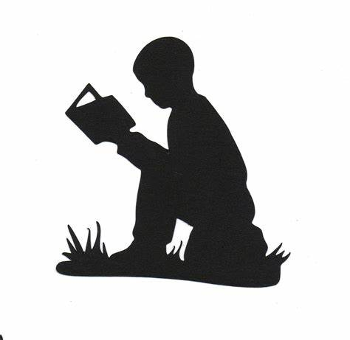

Presented by the 2021 - 2023
National Educational Committee

Becky Cooper, Taygeta Province Trustee, Chairman
Joyce Miller, Alcyone Province
Sharon Everett, Celaeno, Province
Lenore Warne, Electra Province
Kris Douglas, Sterope Province
Susan Stewart, Taygeta Province

DELTA THETA CHI SORORITY
NATIONAL OUTLINE

2023 – 2025

EXTRAORDINARY WOMEN WHO CHANGE HISTORY

While many women are famous for their accomplishments many were chosen for
the fact that their incredible achievements have been overlooked by traditional
History books. Their contributions, great and small, were made in diverse fields ranging from health care to astronomy, from social work, to art, from mathematics to prizewinning writing.

Take Hessie Donahue, a vaudeville performer who became the (unofficial) heavy weight boxing champion of the world when she knocked out prizefighter John Sullivan.

Or Nellie Bly, a nineteenth-century writer, who pretended to be insane in order to report on the inhumwn4 conditions inside the notorious Blackwell’s Island women’s asylum.

Some of the names in this program are very well known and some are not are known. Take some time and research these ladies.

Literature broadly is any collection of written work, but it is also used more narrowly for writings specifically considered to be an art form, especially prose fiction, drama, and poetry. In recent centuries, the definition has expanded to include oral literature, much of which has been transcribed

Women who were extraordinary in Literacy

Belle da Costa Greene - was an American librarian best known for managing and developing the personal library of J. P. Morgan. After Morgan's death in 1913, Greene continued as librarian for his son, Jack Morgan, and in 1924 was named the first director of the Pierpont Morgan Library. Despite being born to Black parents, Greene spent her professional career passing for white.
Katharine Meyer Graham - was an American newspaper publisher. She led her family's newspaper, The Washington Post, from 1963 to 1991. Graham presided over the paper as it reported on the Watergate scandal, which eventually led to the resignation of President Richard Nixon. She made the historic decision to publish the Pentagon Papers, documents about Vietnam War. She was the winner of the Pulitzer Prize for Biography,
Helen Adams Keller - was an American author, disability rights advocate, political activist and lecture. She lost her sight and herring at the age of 19 month. She learned to read and write. She attended Radcliffe College of Harvard University and became the first death and blind person to earn as Bachelor Arts degree
Maya Angelou - such as her autobiography I Know Why the Caged Bird Sings. Born in St. Louis, Missouri, in 1928, Angelou fought back against a society filled with racism and prejudice to write than 30 books, direct 1998's Down in the Delta starring Alfie Woodard and Wesley Snipes, recite one of her poems at Bill Clinton’s inauguration, and be awarded the Presidential Medal of Freedom by President Barack -Obama in 2010
Brooks Gwendolyn - An American poet, author, and teacher. Her work often dealt with the person - al celebrations and struggles of ordinary people in her community. She won a Pulitzer Prize for Poetry, on May 1, 1950, for Annie Allen, making her the first African American to receive a Pulitzer Prize. She was known around the world for using poetry to increase understanding about black culture in America
Edith Wharton - was an American novelist, short writer and designer. She drew upon her insider knowledge of the upper class New York “aristocracy” to realistically portray the lives and morals of the Gilded Age. In 1921, Edith Wharton became the first woman to win the Pulitzer Prize for Fiction for her novel The Age of Innocence
Katherine Lee Bates - was an American author and poet, chiefly remembered for her anthem "America the Beautiful", but also for her many books and articles on social reform, on which she was a noted speaker.

Music is generally defined as the art of arranging sound to create some combination of form, harmony, melody, rhythm or otherwise expressive content. Exact definitions of music vary considerably around the world,

Extraordinary women in the area of music

Carly Simon - American singer-songwriter, musician, and children’s author. She has authored five children’s books as well. Simon’s very unique and beautiful voices makes you stop and listen, Her songs can be described as reflective, evidently inspired by her experience and people in her life. Her passion for music can be seen in her body and her many achievement.
Beverly Sills - Opera soprano was called “American’s Queen of Opera” by Time Magazine, and known as “Bubbles’’ to her fans, was the face of opera for millions through her public performance, recordings and broadcasts during a singing of more than four decades.
Philippa Duke Schuyler - was an American pianist, composer, author, and journalist. A child prodigy, she was the daughter of black journalist George Schuyler and Josephine Schuyler, a white Texan heiress. She began writing at two and a half and composing at four. At five she was playing Mozart for audiences she and at ten she joined the National Association of Compose and Conductors.
Marian Anderson - singer displayed vocal talent as a child, but her family could not afford to pay for formal training. Members of her church congregation raised funds for her to attend a music school for a year. In 1955 she became the first African American singer to perform as a member of the Metropolitan Opera in New York City
Singer Karen Carpenter - started performing with her brother Richard as a teenager. The pair later became world famous as Carpenters, one of the 1970s biggest soft rock acts. They landed their first number-one hit with “(They Long to Be) Close to You” in 1970. More hits soon followed, including “Rainy Days and Mondays” and “Top of the World”.

Whitney Houston - the most awarded female artist of all-time. She started singing as a young girl in church, and never stopped, becoming a household name who still holds the record for bestselling single. Anyone heard of a little song called “I Will Always Love You”.
Selena Quintanilla Pérez, known mononymously as Selena, was an American Tejano singer. Called the "Queen of Tejano music", her contributions to music and fashion made her one of the most celebrated Mexican-American entertainers of the late 20th century.
Mariah Carey - This star is all we want for Christmas and more. She also has five Grammys and a dozen other accolades from her record breaking career and vocal range, making her one of the wealthiest female artist in the world
Rita Moreno - a Puerto Rican actress, dancer, and singer. Noted for her work across different areas of the entertainment industry, she has appeared in numerous film, television, and theater projects throughout her extensive

Art is a diverse range of human activity, and resulting product, that involves creative or imaginative talent expressive of technical proficiency, beauty, emotional power, or conceptual ideas. There is no generally agreed definition of what constitutes art, and its interpretation has varied greatly throughout history and across cultures.

Women who were extra ordinary in their field of Art

Amy Sheral - American Artist who is known for lards scale portraits. She painted the official portrait of former first lady, Michelle Obama.
Andrea Bowers (born 1965) - a Los Angeles-based American artist working in a variety of media including video, drawing, and installation. Her work has been exhibited around the world, including museums and galleries in Germany, Greece, and Tokyo. Her work was included in the 2004 Whitney Biennial and 2008 California Biennial. She is on the graduate faculty at Otis College of Art and Design
Katherine Sue Opie - an American fine-act photographer who specializing in portraiture, studio and landscape photography. Her style mixes traditional photography and unconventional subjects. She is known for her portraits exploring the Los Angeles leather-dyke community.
Margaret Bourke-White - an American photographer and documentary photographer, became arguably best known as the first foreign photographer permitted to take pictures of Soviet industry under the Soviets' five-year plan, as the first American female war photojournalist, and for having one of her photographs on the cover of the first issue of Life magazine.
Coco Chanel - famous for her timeless designs, trademark suits and little black dresses. In the 1920s, she launched her first perfume and eventually introduced the Chanel suit and the little black dress, with an emphasis on making clothes that were more comfortable for women. She herself became a much revered style icon known for her simple yet sophisticated outfits paired with great accessories, such as several strands of pearls.

Politics is the set of activities that are associated with making decisions in groups, or other forms of power relations among individuals, such as the distribution of resources or status
Science is a systematic endeavor that builds and organizes knowledge in the form of testable explanations and predictions about the universe.
Science may be as old as the human species, and some of the earliest archeological evidence for scientific reasoning is tens of thousands of years old. The earliest written records in the history of science come from Ancient Egypt and Mesopotamia in around 3000 to 1200 BCE

Women who were extraordinary in the fields of politics and science

Catherine Ann” Kate” Barnard - first women to be elected as a state official in Oklahoma, and the second women to be elected to a statewide public office in the United States. Commissioner of Charities and Correction.
Barbara Charline Jordan - American lawyer, educator, politician who was a leader in Civil Rights Movement. She was the first African American elected to the Texas Senate after Reconstruction and the first Southern African-American women to be elected to United States House of Representatives.
Sandra Day O’Connor -1981 first women appointed to the U.S. Supreme Court. She was the key swig vote in upholding bug cases like Roe v. Wade.
Shirley Chisholm - In 1968 she became the first Black women to be elected into Congress. As activist and a political leader, she entered the 1975 Democratic presidential race-the first women and the first Black American to do so.
Michelle Obama - she is a lawyer, writer, and wife of the 44th President. She has four main initiatives, she has become a role model for women and an advocate for healthy families, service members and their families, higher education and international adolescent girl’s education.
Lillian Eugen Smith - a writer and social critic of the Southern United States, known for both her non-fiction and fiction works, including the best-selling novel Strange Fruit. Smith was a white woman who openly embraced controversial positions on matters of race and gender was equality.
Suzettes Ls Fleche - well-known Native American writer, lecturer, interpreter, and artist of the Omaha tribe in Nebraska. La Fleche was a progressive who was a spokesperson for Native American rights.
Margaret Chase Smith - A member of the Republican Party, she served as a U.S. representative and a U.S. senator from Maine. She was the first woman to serve in both houses of the United States Congress, and the first woman to represent Maine in either.
Margaret Brown - A look at the extraordinary life of Margaret Brown, best known as 'Unsinkable Molly Brown' after she survived the 1912 RMS Titanic disaster. She later became an activist for workers' and women's rights and made a bid for election six years before women had the right to vote.
Jacqueline Lee Bouvier Kennedy Onassis - was the wife of the 35th president of the United States, John F. Kennedy, and served as First Lady during his presidency from 1961 until his assassination in 1963. She was later married to Greek shipping magnate Aristotle Onassis from 1968 until his death in 1975. In later years she had a successful career as a book editor, and is remembered for her style and elegance.
Margaret Hamilton - American computer scientist, systems engineer, and business owner. She was director of the Software Engineering Division of the MIT Instrumentation Laboratory, which developed on-board flight software which developed on-board flight software for NASA's Apollo program. On November 22, 2016, Hamilton received the Presidential Medal of Freedom from Barack Obama for her work leading to the development of on-board flight software for NASA's Apollo Moon missions.
Katherine Johnson - a mathematician who was one of NASA's human "computers" and an unsung hero of the space agency's early days. She calculated the flight path for America's first crewed space mission and moon landing
Radium Girls - The Radium Girls were female factory workers who contracted radiation poisoning from painting watch dials with self-luminous paint
Hedy LaMarr - The “Golden Age” actress was credited for helping to co-invent a radio signaling devise, a.k.a, a Secret Communication System. The system changed radio frequencies to confuse and hinder enemies during World War II, and it’s a crucial part of how we communicate wirelessly today
Dr. Sally Ride - was an American astronaut and physicist. Born in Los Angeles, she joined NASA in 1978, and in 1983 became the first American woman and the third woman to fly in space, after cosmonauts Valentina Tereshkova in 1963 and Svetlana Savitskaya in 1982.
Amelia Earhart - In 1928 Earhart was the first female pilot to fly across the Atlantic Ocean. She was also the 16th women to be issued a pilot’s license. She mysteriously disappeared during a flight in 1937 and was pronounced legally dead two years later
Henrietta Lacks - an African-American woman whose cancer cells are the source of the HeLa cell line, the first immortalized human cell line and one of the most important cell lines in medical research.
Mae Jemison - in 1992, when the space shuttle Endeavour blasted off, NASA astronaut Mae Jemison became the first African American woman to reach space. But astronaut is just one of her many titles. Jemison is also a physician, a Peace Corps volunteer, a teacher, and a founder and president of two technology companies, according to Space.com.

